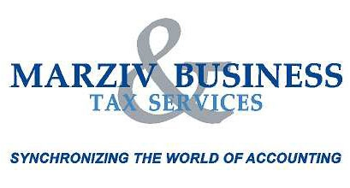
We want to make sure we maximize your refund and get you
every tax credit and deduction you’re entitled to for you 2011 Tax Year

So before you visit the Marziv Business & Tax Solutions Inc. location, make sure you have all the receipts and income records your tax consultant will need to help minimize your taxes.
Here’s a handy checklist:
Slips:
- All T4 slips
- All other information slips (T3, T5, T4E, T4A, T4AP, T4RSP, T4RIF)
- Employment income (i.e. pay cheque stubs)
- Old Age Security and CPP benefits
- Other pensions and annuities
- Employment Insurance benefits
- Social assistance payments
- Workers’ compensation benefits

Receipts
- Interest and dividends
- Sale or deemed sale of stocks, bonds or real estate
- Support for a child, spouse or common-law partner
- RRSP contributions
- Professional fees or Union dues
- Tool expenses (tradespersons)
- Medical expenses
- Tuition/Education amounts for qualifying students
- Transit passes
- Charitable donations
- Political contributions
- Child care expenses
- Adoption expenses
- Children’s fitness programs
- Ontario Children’s Activity Tax Credit
- Moving expenses
- Interest paid on student loans
- Carrying charges and interest expenses
- Automobile expenses
- Travel expenses
- Office-in-home expenses

Other Documentation
- Universal Child Care Benefit confirmation
- Notice of Assessment
- Canada Revenue Agency correspondence
- Capital gains/losses records
- Northern residents deductions
- Rental income & expense records
- Business, farm or fishing income & expense records
- Disability Tax Credit Certificate (T2201)
- Declaration of Conditions of Employment (T2200)

